Request to Transfer Student in GOLD Online System
Whenever student information is sent to the Iowa Department of Education (DE), the Iowa GOLD Transfer Form must be password protected. The DE will NOT accept an Iowa GOLD Transfer Form containing student information unless the form is protected by a password.

This change in procedure is needed to protect our students’ personally identifiable information. Personally identifiable information can include a student’s name and date of birth.
A request to transfer a preschool student between preschool programs in the My Teaching Strategies GOLD online system will require two e-mail messages to the DE. The first message will contain the password protected Iowa GOLD Transfer Form. A second, separate e-mail message will contain the password that opens the Iowa GOLD Transfer Form.

When requesting the transfer of a preschool student in the GOLD system:
- Enter all information into the transfer form. The form is located on the second page of this document.
- Password protect the document (See information below on how to password protect a Word document).
- Send the Iowa GOLD Transfer Form to mary.breyfogle@iowa.gov. Do NOT include the password in the message containing the completed form.
- Send the password to open the Iowa GOLD Transfer Form in a SEPARATE e-mail message. Do NOT enter any personally identifiable information in the e-mail message body or subject heading.

How to password protect the Iowa GOLD Transfer Form

Do not use the student name when naming and saving the Iowa GOLD Transfer Form.
1. Select “Save As” to save the Iowa GOLD Transfer Form to your computer. THE “Save As” OPTION MUST BE USED TO PASSWORD PROTECT WORD DOCUMENTS.
2. BEFORE clicking the “Save” button, click the “Tools” button (located in bottom right corner of the screen.)
3. Choose “General Options” from the Tools menu.
4. In the General Options dialogue box enter the password in the text box after the phrase “Password to open”. Click “OK”.
5. A “Confirm Password” dialogue box will appear to confirm the password. Reenter the password.
6. Click “OK” to confirm password.
7. Complete the password protection process by clicking the “Save” button.
Send the protected Iowa GOLD Transfer Form to mary.breyfogle@iowa.gov. Send the password in a second, separate e-mail message to the same e-mail address.

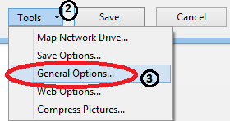
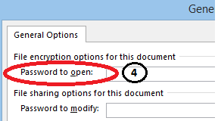
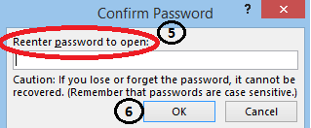

Iowa GOLD Transfer Form
Please supply all information requested below and send the password protected Iowa GOLD Transfer Form to mary.breyfogle@iowa.gov.

Primary Information
Child Information
Child ID (State ID):
First Name:
Last Name:
Date of Birth:
**************************************************************
Person Requesting Transfer
First Name:
Last Name:
E-Mail Address:
Please Confirm E-Mail Address:

******************************************************************************************************************
Transfer Information
Date of transfer
Please use mm/dd/yyyy format:

**************************************************************
Current Program (Transfer Child from Program)
Program Name:
Site Name:
Teacher or Class Name (Designate AM or PM if applicable):

**************************************************************
Receiving Program (Transfer Child to Program)
Program Name:
Site Name:
Teacher or Class Name (Designate AM or PM if applicable):

**************************************************************

